
MANAGING A STREAM
Step 1. Select the appropriate teams playing game.
Step 2. Click the Start game button
Step 3. Adjust score by clicking the and innings throughout game play.
Step 4. Click the Finish game button

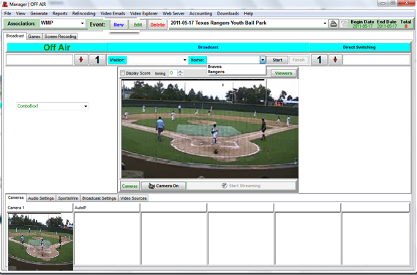

Note: Do not stop streaming unless the days streaming is over. If streaming is disabled or stopped by the software go ahead and stop the broadcast and restart the broadcast by clicking the Start Streaming button. Also check your audio settings and make sure the correct audio source is selected.

